1. Challenges are not the disadvantages of microservices. So don’t think that we should go for monolithic app.
2. 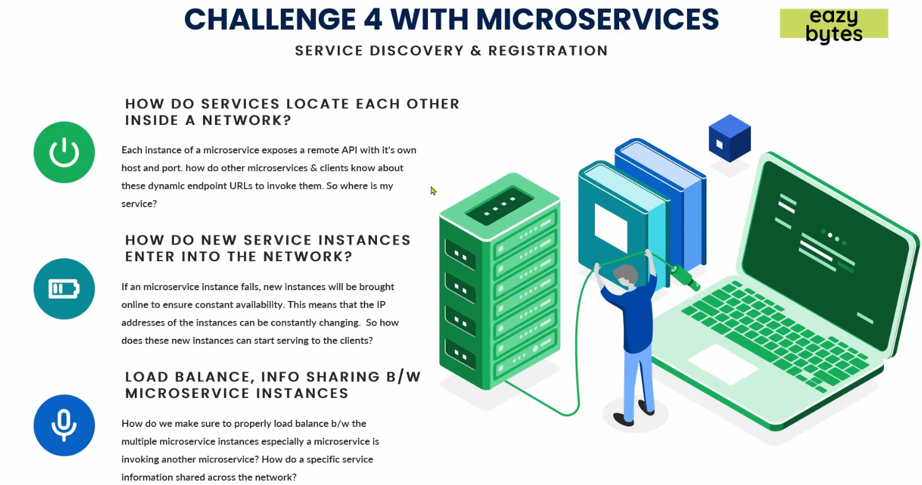
3. First Question.
   1. Suppose you have 100 microservices and each has 10 instances.
   2. Each microservice has its own IP, port, end-point URL.
   3. Question is how each microservice locates each other inside a network.
   4. In microservice architecture, we scale up or down microservice as per our need so IP and Port are dynamic in nature which is not in monolithic where we can put this info in some property file.
   5. So suppose we have account microservice which
4. Second Question:
   1. A microservice is scaled up and how does this new instance register its IP, port and endpoint so that other microservices can consume it.
5. Third Question:
   1. How to balance load b/w different instances of a microservice.
   2. How to share info from one micro to another micro.
6. Solution:
   1. This all will be solved with a pattern called “Service Discovery & Registration Pattern”.

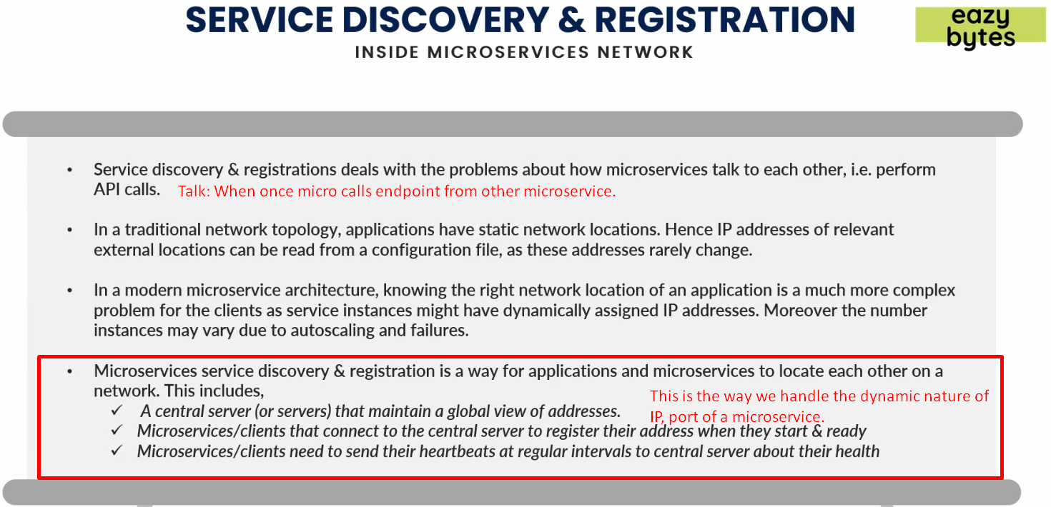

1. In “Service Discovery & Registration”, we follow 3 steps.
   1. A Central Server(s):
      1. Suppose we have 100 microservices. It will handle the IPs, ports and endpoints of all those microservices.
   2. Each new instance of a microservice needs to get itself registered with this Central Microservice.  
      The new instance will register its IP, port and all other info with Central Server.
   3. After a specific interval of time, each instance sends a heartbeat to this central server for its ok health.  
      So, if central server doesn’t receive heartbeat from a particular instance, it will remove all the registered info for that instance so that no other microservice can invoke any endpoint from that instance.
2. So, in this way, “Service Discovery and Registration” helps us to maintain the network topology inside microservice architecture by addressing all the above 3 issues in our microservice.